Digital Clock using

Tinkercad

Guide : - Ashok sir .

Rutuj Nagrale , Rucha Nagre

Suimaiyaa Nadaf

Vishawakarma institute of

Techonology(DESH)

Abstract : - Building a new digital clock using components in Tinkercad .

Keyword : - Arduino Board UNO

R3 , LCD , buttons .

Aim : - Aim to make a fully functional digital clock in which a user can set a time.

Introduction

A digital clock is a type of clock that displays the time digitally (i.e. in numerals or other symbols), as opposed to an analogue clock. Digital clocks are often associated with electronic drives, but the "digital" description refers only to the display, not to the drive mechanism.

The working principle of the digital timer is, it uses the power source and different electronic components for a time like hours, minutes and seconds. The power source of this timer is either a battery otherwise a power cable connection or the clock gearing controlled by the counter.

So with the help of Tinkarcad

Circuits it will be the easiest way to learn new electronics devices. **Tinkercad** is a free, easy-to-use web app that equips the next generation of designers and engineers with the foundational skills for innovation: 3D design and many more.

List of Components Used

* Arduino UNO R3
* LCD 16 x 2
* 1 kohm Resistor
* 220 ohm Resistor
* Push Button

Arduino

Arduino/Genuino Uno is a microcontroller board based on the ATmega328P (datasheet).

It has 14 digital input/output pins (of which 6 can be used as PWM outputs), 6 analog inputs, a 16 MHz quartz crystal, a USB connection, a power jack, an ICSP header and a reset button.

It contains everything needed to support the microcontroller; simply connect it to a computer with a USB cable or power it with a AC-to-DC adapter or battery to get started..

"Uno" means one in Italian and was chosen to mark the release of Arduino Software (IDE) 1.0.

The Uno board and version 1.0 of Arduino Software (IDE) were the reference versions of Arduino, now evolved to newer releases.

The Uno board is the first in a series of USB Arduino boards, and the reference model for the Arduino platform; for an extensive list of current, past or outdated boards see the Arduino index of boards.

LCD 16 x 2

LCD (Liquid Crystal Display) is a type of display that uses liquid crystals for its operation. A 16×2 LCD means there are 16 columns and 2 rows. Therefore a maximum of 32 characters can be displayed at a time.

All characters are displayed in a 5×7 pixel matrix format in 16X2 LCD. Other Various configurations include (1 line by 20 X char up to 8 lines X 80). This LCD has two registers, namely, Command and Data.

The command instructions given to the LCD are stored in the command register. For performing various tasks like LCD initialization, clearing the display, assigning cursor positions, text display location, etc., various commands are given to LCD in hexadecimal format.

The data register is used to display data on LCD. The data is the ASCII value of the character to be displayed on the LCD.

Resistor

A resistor is a passive two-terminal electrical component that implements electrical resistance as a circuit element.

Resistors reduce current flow in electronic circuits, a property that is utilized to adjust signal levels, to divide voltages, bias active elements, and terminate transmission lines, among other uses.

High-power resistors that can dissipate many watts of electrical power as heat may be used as part of motor controls, in power distribution systems, or as test loads for generators.

Fixed resistors have resistances that only change slightly with temperature, time or operating voltage.

Variable resistors can be used to adjust circuit elements (such as a volume control or a lamp dimmer), or as sensing devices for heat, light, humidity, force, or chemical activity.

Push Button

A push-button (also spelled pushbutton) or simply button is a simple switch mechanism to control some aspect of a machine or a process. Buttons are typically made out of hard material, usually plastic or metal.

The surface is usually flat or shaped to accommodate the human finger or hand, so as to be easily depressed or pushed.

Buttons are most often biased switches, although many un-biased buttons (due to their physical nature) still require a spring to return to their un-pushed state.

Terms for the "pushing" of a button include pressing, depressing, mashing, slapping, hitting, and punching.

The "push-button" has been utilized in calculators, push-button telephones, kitchen appliances, and various other mechanical and electronic devices, home and commercial.

Execution process

First after completing the design part and also coding , we will start the simulation of the digital clock using Arduino with the help of Autocard Tinkercad website. So after starting the simulation the clock will start working form start 00 : 00 and date 01 and also month 01 . So this digital clock also contain three buttons , which is Set , Up

and Down . So to change the time we have to use this three buttons.

So when we start simulation it will start working and when we will push Set button the clock will stop working and now we can start changing time. So first we can change the hour time for example we have time as 19:25 March 17 . So with the help of up button we can up the time and with down we can down the time . And when we again push the set button now we can change the minute time and with the help of up and down we can make modify in minute time . And again if we push set it will change the date and again if we push that button we can change month .

And again, if we click on set the clock will start working form the time where we have set it.

Limitations

* This digital clock does not contain a alarm system.
* In this digital clock we can't change the seconds settings like we can change hour , minutes , dates and months.

Result and Discussion

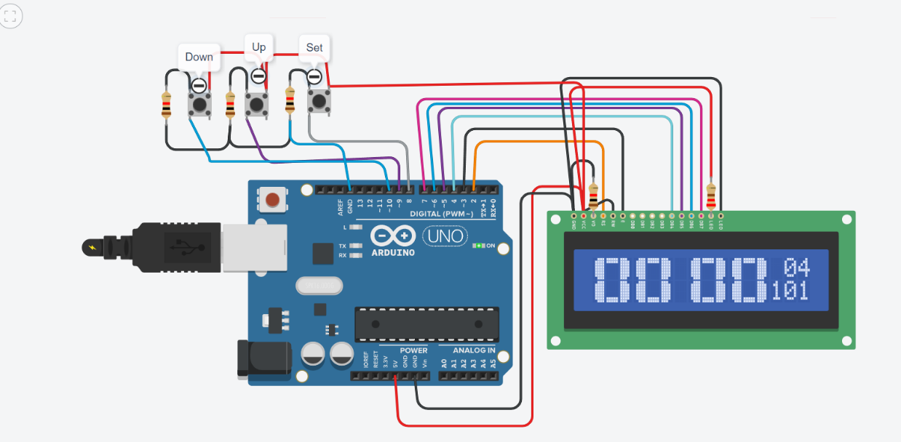

Figure 1 :- When we will start the simulation

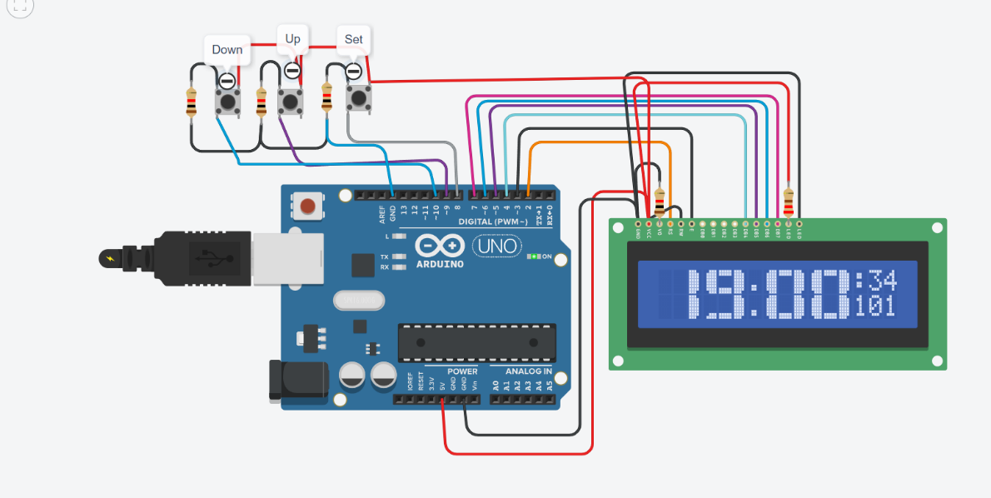

Figure 2 :- When we will change the hour side in clock

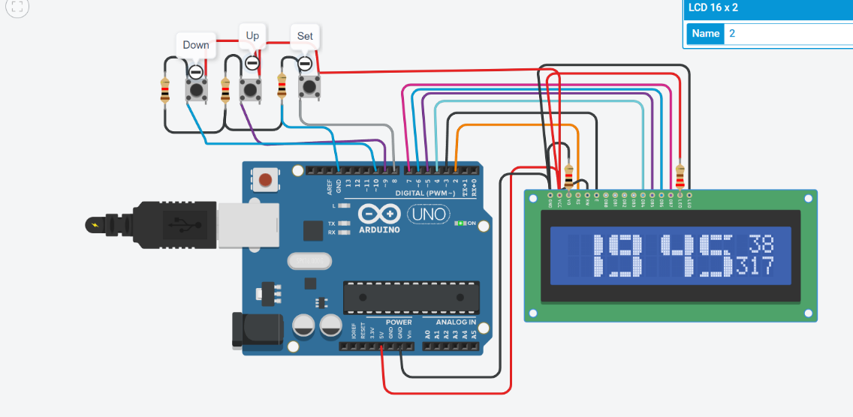

Figure 3 : - After changing hour , minute , date and month

Schematic view of digital clock

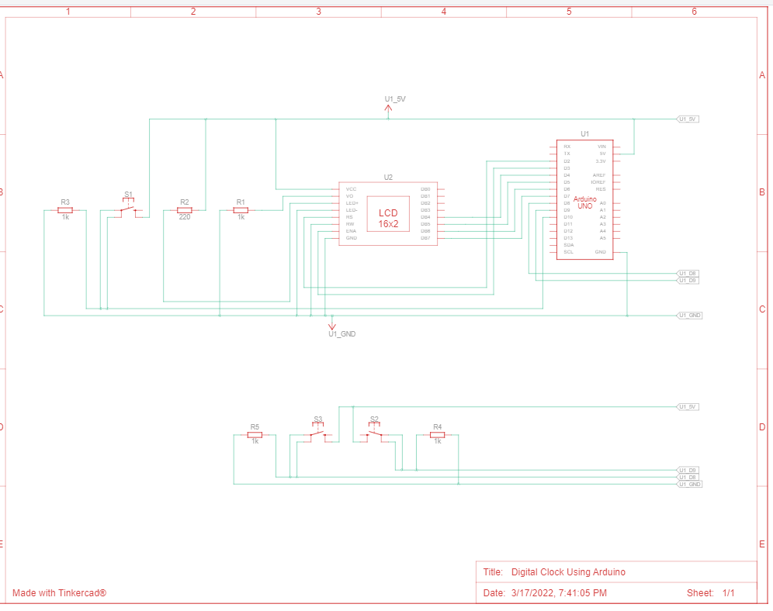

Future scope

* To make a alarm noise at a particular time by a user
* Can also change the seconds settings.